​
​
​
​
​ |  | ​ | ​
UNITED STATES
SECURITIES AND EXCHANGE COMMISSION
WASHINGTON, D.C. 20549
SCHEDULE 14A
Proxy Statement Pursuant to Section 14(a) of the Securities
Exchange Act of 1934
Filed by the Registrant ☒
Filed by a Party other than the Registrant ☐
Check the appropriate box:
☐ | Preliminary Proxy Statement
☐ | Confidential, for Use of the Commission Only (as permitted by Rule 14a-6(e)(2))
☒ | Definitive Proxy Statement
☐ | Definitive Additional Materials
☐ | Soliciting Material Pursuant to §240.14a-11(c) or §240.14a-12
​ |  | Hoyne Bancorp, Inc. | ​
(Name of Registrant as Specified In Its Charter)
​ |  | ​ | ​
(Name of Person(s) Filing Proxy Statement, if other than the Registrant)
Payment of Filing Fee (Check the appropriate box):
☒ | No fee required.
☐ | Fee paid previously with preliminary materials.
☐ | Fee computed on table in exhibit required by Item 25(b) per Exchange Act Rules 14a6(i)(1) and 0-11
​
​
​
​
​
​
​

​
Hoyne Bancorp, Inc.
810 S. Oak Park Ave.
Oak Park, Illinois 60304
(708) 434-4300
April 23, 2026
​
Dear Fellow Stockholder:
The 2026 Annual Meeting of Stockholders of Hoyne Bancorp, Inc. will be held at Butterfield Country Club at 2800 Midwest Road, Oak Brook, Illinois on Thursday, May 28, 2026, at 4:00 p.m., Central Time.
The enclosed Notice of Annual Meeting and Proxy Statement describe the formal business to be transacted at the Annual Meeting. Also enclosed is our Annual Report on Form 10-K for the year ended December 31, 2025, which contains information concerning our business and 2025 financial performance. Our directors and executive officers, as well as a representative of our independent registered public accounting firm, are expected to be present at the Annual Meeting to respond to any questions that stockholders may have.
The business to be conducted at the Annual Meeting consists of: (1) the election of directors, and (2) the ratification of the appointment of Wipfli LLP as our independent registered public accounting firm for the year ending December 31, 2026. The Board of Directors has determined that the matters to be considered at the Annual Meeting are in the best interest of Hoyne Bancorp, Inc. and its stockholders, and the Board of Directors unanimously recommends a vote “FOR” each matter to be considered.
On behalf of the Board of Directors, we urge you to sign, date and return the enclosed proxy card, or vote your shares online, as soon as possible to ensure that your shares are represented and voted at the meeting. This will not prevent you from attending the meeting and voting in person, but will assure that your vote is counted if you are unable to attend the Annual Meeting.
The Proxy Statement and the 2025 Annual Report on Form 10-K are also available at https://annualgeneralmeetings.com/hyne2026 and at Hoyne’s website at https://investors.hoyne.com/financial-information/sec-filings.
​ | Sincerely,  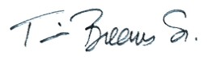  Timothy S. Breems, Sr.  Chairman of the Board
​
​
​

​
Hoyne Bancorp, Inc.
810 S. Oak Park Ave.
Oak Park, Illinois 60304
(708) 434-4300
NOTICE OF
ANNUAL MEETING OF STOCKHOLDERS
To Be Held on May 28, 2026
Notice is hereby given that the 2026 Annual Meeting of Stockholders of Hoyne Bancorp, Inc. will be held at Butterfield Country Club at 2800 Midwest Road, Oak Brook, Illinois on Thursday, May 28, 2026, at 4:00 p.m., Central Time.
A proxy card and the Proxy Statement for the Annual Meeting are enclosed. The Annual Meeting is for the purpose of considering and acting upon:
 | 1. | the election of three directors identified in the proxy statement for a term expiring at the 2029 Annual Meeting; and
 | 2. | the ratification of the appointment of Wipfli LLP as independent registered public accounting firm for the year ending December 31, 2026.
Stockholders also will transact any other business that may properly come before the Annual Meeting, or any adjournments thereof, as determined by the Board of Directors. The Board of Directors currently is not aware of any other business to come before the Annual Meeting.
Any action may be taken on the foregoing proposals at the Annual Meeting on the date specified above, or on the date or dates to which the Annual Meeting may be adjourned or postponed. Stockholders of record at the close of business on April 7, 2026 are the stockholders entitled to vote at the Annual Meeting, and any adjournments or postponements thereof.
Please submit a proxy as soon as possible so that your shares can be voted at the meeting in accordance with your instructions. You may submit your proxy (1) through the Internet or (2) by completing, signing, dating and returning the enclosed proxy card in the enclosed postage-paid envelope by mail. For specific instructions, please refer to the accompanying proxy card. Any stockholder present at the Annual Meeting may revoke his or her proxy and vote personally on each matter brought before the Annual Meeting. However, if you are a stockholder whose shares are not registered in your own name, you will need additional documentation from your record holder in order to vote in person at the Annual Meeting. Attendance at the Annual Meeting will not in itself constitute revocation of your proxy.
​
​
We also are soliciting voting instructions from participants in the Hoyne Savings Bank Employee Stock Ownership Plan (“ESOP”) who may direct the ESOP trustee to vote shares on their behalf under the ESOP. We ask each plan participant to sign, date and return the accompanying voting instruction card or provide voting instructions through the Internet as described on the voting instruction card.
​ | By Order of the Board of Directors,  ​  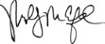  Molly M. Crawford  Corporate Secretary
​
Oak Park, Illinois
April 23, 2026
YOUR VOTE IS IMPORTANT
Please vote via the Internet or Mail.
Internet Availability of Proxy Materials:
https://annualgeneralmeetings.com/hyne2026
If you are voting by mailing your proxy card, please mark, sign and date the proxy card and return it promptly in the self-addressed, stamped envelope that we have provided. No postage is required if mailed within the United States.
The prompt return of proxies will save the expense of further requests for proxies.
​
2

PROXY STATEMENT
of
HOYNE BANCORP, INC.
810 S. OAK PARK AVE.
OAK PARK, ILLINOIS
ANNUAL MEETING OF STOCKHOLDERS
To be held on May 28, 2026
This Proxy Statement is furnished in connection with the solicitation of proxies by the Board of Directors of Hoyne Bancorp, Inc. (the “Company”) to be used at the Company’s Annual Meeting of Stockholders to be held at Butterfield Country Club, 2800 Midwest Road, Oak Brook, Illinois, on May 28, 2026, at 4:00 p.m., Central Time (the “Annual Meeting”). The accompanying Notice of Annual Meeting and this Proxy Statement are being first mailed to stockholders on or about April 23, 2026.
At the Annual Meeting, stockholders will consider and vote upon: (1) the election of three directors of the Company, each to serve a three-year term, and (2) the ratification of the appointment of Wipfli LLP as the Company’s independent registered public accounting firm for the fiscal year ending December 31, 2026.
VOTING AND PROXY PROCEDURES
Who Can Vote at the Annual Meeting
You are only entitled to vote at the Annual Meeting if our records show that you held shares of our common stock, par value $0.01 per share (the “Common Stock”), as of the close of business on April 7, 2026 (the “Record Date”). If you wish to attend and vote your shares at the Annual Meeting and your shares are held by a broker or other intermediary, you can only vote your shares at the Annual Meeting if you have a properly executed proxy from the record holder of your shares (or their designee). As of the Record Date, a total of 8,096,938 shares of Common Stock were outstanding. Except as otherwise noted below, each share of Common Stock has one vote on each matter presented. A majority of the outstanding shares of the Company’s common stock entitled to vote, represented in person or by proxy, will be necessary to constitute a quorum at the Annual Meeting.
Voting by Proxy
The Board of Directors is sending you this Proxy Statement for the purpose of requesting that you allow your shares of Common Stock to be represented at the Annual Meeting by the persons named in the enclosed proxy card. As shown on your proxy card, you may also vote your shares by Internet voting. All shares of Common Stock represented at the Annual Meeting by properly submitted and dated proxies will be voted according to the instructions indicated on the proxy. If you execute a proxy (by any permitted method) without giving voting instructions, your shares will be voted as recommended by the Company’s Board of Directors.
The Board of Directors recommends a vote “FOR” its nominees for directors, and “FOR” the ratification of the appointment of Wipfli LLP as our independent registered public accounting firm.
The Company does not know of any other matters to be presented at the Annual Meeting. If any matters not described in this Proxy Statement are properly presented at the Annual Meeting, the persons named in the proxy will vote
3
your shares as determined by a majority of the Board of Directors. If the Annual Meeting is postponed or adjourned, your shares of Common Stock may be voted by the persons named in the proxy card on the new Annual Meeting date as well, unless you have revoked your proxy. You may revoke your proxy at any time before the vote is taken at the Annual Meeting. To revoke your proxy you must advise the Company’s Corporate Secretary in writing before your Common Stock has been voted at the Annual Meeting, deliver a later-dated proxy (executed in writing or via the Internet), or attend the Annual Meeting and vote your shares in person. Attendance at the Annual Meeting will not in itself revoke your proxy.
If you hold your Common Stock in “street name,” you will receive instructions from your broker, bank or other nominee that you must follow in order to have your shares voted. Your broker, bank or other nominee may allow you to deliver your voting instructions via the Internet.
Please see the instruction form provided by your broker, bank or other nominee that accompanies this Proxy Statement. In order to vote in person at the Annual Meeting, you will need special documentation from your broker, bank or other nominee. Please note that pursuant to the rules that guide how brokers vote your stock, your brokerage firm or other nominee may not vote your shares with respect to the election of directors (Proposal 1) without specific instructions from you as to how to vote because it is not considered a “routine” matter under the applicable rules. Proposal II is a matter we believe will be considered “routine”; even if the broker or other nominee does not receive instructions from you, the broker or other nominee is entitled to vote your shares in connection with Proposal 2.
Solicitation of Proxies; Expenses
We will pay the cost of this proxy solicitation. Our directors, executive officers and other employees may solicit proxies by mail, personally, by telephone, by press release, by facsimile transmission or by other electronic means. No additional compensation will be paid to our directors, executive officers or employees for such services. We will reimburse brokerage firms and other custodians, nominees, and fiduciaries for reasonable expenses incurred by them in sending proxy materials to the beneficial owners of our Common Stock.
Participants in the Hoyne Savings Bank Employee Stock Ownership Plan
If you are a participant in the Hoyne Savings Bank Employee Stock Ownership Plan (“ESOP”), you will receive a voting instruction card that reflects all the shares that you may direct the ESOP trustee to vote on your behalf under the ESOP. Under the terms of the ESOP, the ESOP trustee votes all shares held by the ESOP, but you may direct the trustee how to vote the shares of Common Stock allocated to your ESOP account. The ESOP trustee will vote all unallocated shares of Common Stock held by the ESOP, all allocated shares for which no voting instructions are received and all allocated shares for which participants have voted “abstain” in the same proportion as shares for which it has received timely voting instructions.
Quorum and Vote Required
Business cannot be transacted at the Annual Meeting unless a quorum is present. A majority of the outstanding shares of the Company entitled to vote, represented in person or by proxy, constitutes a quorum at the Annual Meeting. Abstentions and broker non-votes will be counted for purposes of determining that a quorum is present. A “broker non-vote” occurs when a broker, bank or other nominee holding shares for a beneficial owner does not have discretionary voting power with respect to the agenda item and has not received voting instructions from the beneficial owner. In the event there are not sufficient shares represented in person or by proxy for a quorum, or to approve or ratify any matter being presented at the time of the Annual Meeting, the Annual Meeting will be adjourned in order to permit further solicitation of proxies.
In voting on the election of directors (Proposal 1), you may (i) vote for all the nominees; (ii) vote to withhold for all the nominees; or (iii) vote for all nominees except one or more of the nominees. There is no cumulative voting in the election of directors. Directors are elected by a plurality of the votes cast at the Annual Meeting. This means that the nominees who receive the highest number of votes cast are elected, up to the maximum number of directors to be elected at the Annual Meeting. Votes that are withheld and broker non-votes will have no effect on the outcome of the election.
4
In voting to ratify the appointment of Wipfli LLP as our independent registered public accounting firm for the fiscal year ending December 31, 2026 (Proposal 2) you may (i) vote for the ratification; (ii) vote against the ratification; or (iii) abstain from voting on such ratification. To be approved, this proposal requires the affirmative vote of a majority of the votes cast at the Annual Meeting. Broker non-votes and abstentions will not be counted as votes cast and will have no effect on the voting on these proposals.
Under rules applicable to broker-dealers, the proposal to ratify the independent registered public accounting firm is considered a “discretionary” item upon which brokerage firms may vote in their discretion on behalf of their clients if such clients have not furnished voting instructions. The election of directors is considered “non-discretionary” for which brokerage firms may not vote in their discretion on behalf of clients who do not furnish voting instructions and, thus, there may be broker non-votes at the Annual Meeting. You should use the proxy card provided by the institution that holds your shares to instruct your broker to vote your shares, or submit your vote online by following the instructions on the proxy card, to avoid your shares being considered broker non-votes.
Limitation on Voting
Our Certificate of Incorporation provides that in no event will any person who beneficially owns more than 10% of the then-outstanding shares of Common Stock be entitled or permitted to vote any of the shares of Common Stock held in excess of the 10% limit.
Important Notice Regarding Internet Availability of Proxy Materials
For the Stockholder Meeting to be Held on May 28, 2026
This Proxy Statement and the 2025 Annual Report on Form 10-K are each available at https://annualgeneralmeetings.com/hyne2026. A copy of each document is also available on our website at https://investors.hoyne.com/financial-information/sec-filings.
​
5
PROPOSAL 1 – ELECTION OF DIRECTORS
Our Board of Directors is comprised of nine members. Our Certificate of Incorporation provides that directors are divided into three classes, with one class of directors elected annually. Three directors have been nominated for election at the Annual Meeting to serve for a three-year term and until their respective successors shall have been elected and qualified. The Board of Directors has nominated David M. Opas, Janet H. Winningham and Anthony M. Vaccarello, each to serve as a director for a three-year term expiring at the Company’s annual meeting in 2029. Each nominee is currently a director of Hoyne Bancorp, Inc. and has agreed to serve as a director if elected.
It is intended that the proxies solicited on behalf of the Board of Directors (other than proxies in which the vote is withheld as to any nominee) will be voted at the Annual Meeting for the election of the proposed nominees. If a nominee is unable to serve, the shares represented by all such proxies will be voted for the election of such substitute as the Board of Directors may determine. At this time, the Board of Directors knows of no reason why any of the nominees might be unable to serve, if elected. Except as indicated herein, there are no arrangements or understandings between any nominee or continuing director and any other person pursuant to which such nominee or continuing director was selected.
The following sets forth certain information regarding the nominees, the other current members of our Board of Directors, and executive officers who are not directors. Age information is as of April 7, 2026, and term as a director includes service with Hoyne Savings Bank (the “Bank”). With respect to directors and nominees, the biographies contain information regarding the person’s business experience and the experiences, qualifications, attributes or skills that caused the Board of Directors to determine that the person should serve as a director. Each director of the Company is also a director of the Bank.
Nominees for Director for a Term Expiring in 2029:
David M. Opas, age 74, has served as a director since 2020, and serves on the Audit Committee, the Nominating and Corporate Governance Committee, and as Chair of the Compensation Committee. Mr. Opas previously served as President and Chief Executive Officer of Loomis Federal of Loomis Federal Savings and Loan Association until it was merged into the Bank in 2020. Mr. Opas has a Bachelor’s degree in accounting from Northern Illinois University. His extensive experience provides the Board of Directors with valuable knowledge across multiple disciplines.
Janet H. Winningham, age 74, has served as a director since 2002, and serves on the Compensation Committee and as Chair of the Nominating and Corporate Governance Committee, and on the IT Committee of the Bank. Ms. Winningham has been a practicing attorney for over forty years and is currently in private practice, concentrating in real estate finance, construction and commercial leasing. Ms. Winningham received her law degree from Loyola University of Chicago and her Bachelor’s degree from DePauw University. Ms. Winningham provides the Board of Directors with invaluable legal, real estate, finance and management experience. Ms. Carstensen is the first cousin of Ms. Winningham’s husband.
Anthony M. Vaccarello, age 76, has served as a director of the Bank since 2017, and serves on the Audit Committee and Nominating and Corporate Governance Committee and the CRA Committee of the Bank. Mr. Vaccarello began his career as a staff attorney for Talman Home Federal Savings. Later, he went into private practice, concentrating in real estate, probate, estate planning and condominium law. He also owned and operated a title services agency. Mr. Vaccarello previously was an instructor in the paralegal program at South Suburban College and served in the National Guard. Mr. Vaccarello was previously a director of Prospect Federal Savings Bank until its merger into the Bank in 2017. Mr. Vaccarello has a Bachelor’s degree in economics from St. Joseph’s College and received his law degree from the Loyola University School of Law. He provides the Board of Directors with invaluable legal and property ownership experience.
6
The Board of Directors unanimously recommends a vote “FOR” each of the above nominees for director.
Directors Whose Term Expires in 2027:
Walter F. Healy, age 59, has served as President and Chief Executive Officer of the Bank since September 2024 and a member of the Board of Directors since 2022, prior to which time, he served as President of the Bank from 2023 to 2024 and Executive Vice President, Commercial, from 2022 to 2023. Early in his career, Mr. Healy worked for several Chicago commercial banks. In 1996, working with a group of investors, Mr. Healy started a de novo bank, named Community Bank Oak Park River Forest, in the western suburbs of Chicago. He served as President and Chief Executive Officer through the time of that bank’s successful merger with another bank in Chicago in 2019. Mr. Healy serves on the Loan, ALCO, CRA and IT Committees of the Bank. Mr. Healy received a finance degree from the University of Notre Dame in 1988. His extensive experience in commercial banking provides the Board of Directors with valuable knowledge in connection with the Bank’s business.
Paula M. Carstensen, age 71, has served as a director since 2000, Ms. Carstensen serves on the Audit and Compensation Committees of the Company, and the IT Committee of the Bank. Ms. Carstensen attended the Illinois Institute of Chicago Kent College of Law and was admitted to the Illinois Bar in 1981. Ms. Carstensen began her legal career as a criminal prosecutor in the office of the Cook County State’s Attorney. After leaving public service, she worked as a civil litigation partner in private practice representing clients in the defense of high exposure liability claims and insurance coverage disputes until her retirement from the practice of law in 2019. Ms. Carstensen provides the Board of Directors with invaluable legal and management experience. Ms. Winningham’s husband is Ms. Carstensen’s first cousin.
Judith A. Gonsch, age 73, has served as a director since 2017, and serves as Chair of the Audit Committee and on the ALCO Committee of the Bank. Ms. Gonsch began her career in 1972 at Prospect Federal Savings Bank, advancing through various accounting positions until becoming Chief Financial Officer and Executive Vice President until 2017, when Prospect Federal Savings Bank merged into Bank. Ms. Gonsch has a Bachelor’s degree in accounting from DePaul University. With over 50 years of experience in finance and accounting, Ms. Gonsch provides the Board of Directors with valuable knowledge of the financial aspects of the Bank’s business.
Directors Whose Term Expires in 2028:
Timothy S. Breems, Sr., age 64, has served as a director since 2012 and currently serves as the Chair of the Boards of Directors of Hoyne Bancorp, Inc. and the Bank. Mr. Breems currently serves as a partner in the law firm of Ruff Breems LLP, which he founded in 2022. Prior to the founding of his firm, Mr. Breems worked at the law firm of Ruff, Freud, Breems & Nelson Ltd. from 1983 through July 2022, as a law clerk, associate attorney, partner and ultimately as the firm’s managing partner. He attended DePaul University and received a Bachelor’s degree in Business Administration in 1982, and in 1985, Mr. Breems received his law degree from Loyola University School of Law. Periodically since 2015, Mr. Breems has served as an adjunct professor of Business Law and Contract Law at Trinity Christian College. Mr. Breems is a former President of Southwest Chicago Christian School Association. Mr. Breems’ expansive legal background provides the Board of Directors with valuable information on all aspects of the Bank’s business.
Steven F. Rosenbaum, age 69, has served as a director since 2017, and serves on the Loan, IT and ALCO Committees of the Bank. Mr. Rosenbaum served as President and Chief Executive Officer of the Bank from 2018 to 2023 and Chief Executive Officer from 2023 until his retirement in July 2024. Prior to joining the Bank as President in 2017, he was President and Chief Executive Officer of Prospect Federal Savings Bank from 1998 until 2017, when Prospect Federal Savings Bank merged into the Bank. Mr. Rosenbaum began his banking career at Prospect Federal Savings Bank in 1987 as Executive Vice President and Chief Operating Officer, and he joined the Prospect Federal Savings Bank board of directors in 1995. During his banking career, he has participated in a variety of civic and banking industry activities and organizations. He was a member of the Illinois Bankers Association board of directors from 2019 until 2023. Mr. Rosenbaum received a Bachelor’s degree in political science from DePaul University and a Master’s degree from the Keller Graduate School of Management. His experience in civic and banking industry practices provides the Board of Directors with valuable information on all aspects of the Bank’s business.
7
Theodore C. Wiemann, age 70, has served as a director since 1997 and currently serves as Vice-Chair of the Boards of Directors of the Company and the Bank. He also serves on the CRA, ALCO and Loan Committees of the Bank. Mr. Wiemann began his banking career at the Bank as a part-time employee in 1976, becoming a full-time loan officer in consumer lending in 1977. Mr. Wiemann spent 47 years at the Bank, and at his retirement in 2023, was the Executive Vice President and Chief Lending Officer and Community Reinvestment Officer. Until Mr. Wiemann’s retirement in 2023, he also served on the mortgage markets committee of America’s Community Bankers and the American Bankers Association. Mr. Wiemann graduated from North Park University in 1977 with a major in business management. He then attended the Institute of Financial Education. Mr. Wiemann’s varied experience provides the Board of Directors with valuable information on all aspects of the Bank’s business.
Executive Officer Who is Not a Director
Thomas S. Manfre, age 53, has served as the Executive Vice President and Chief Financial Officer since October 2023, previously serving as Senior Vice President and Chief Risk Officer of the Bank when he first joined the Bank in 2022. Prior to joining the Bank, Mr. Manfre previously served as Senior Vice President, Risk Management Solutions from 2021 to 2022 at Bankers’ Bank. He also served as Executive Vice President, Chief Financial Officer and Chief Operating Officer of FNBC Bank & Trust from 2007 to 2015, at which time he became Senior Vice President, Chief Financial Officer and Head of Retail and Marketing at Community Bank of Oak Park River Forest, which he held until 2019. Mr. Manfre brings more than 30 years of commercial bank management experience through all areas of bank management, including retail, marketing, treasury management, commercial, operational, information technology, investment advisory and financial areas with both de novo and established commercial banks of varying sizes. His management experience includes financial and tax reporting, including holding company reporting, deposit and loan operations, information technology and information security, and he has experience in retail and marketing sales and operation management. Mr. Manfre graduated from the University of Miami in 1995 with a Bachelor’s degree in finance and from DePaul University with a Master’s degree in finance and management in 1999. He also attended the Graduate School of Banking at the University of Wisconsin.
Board Independence
Our Board of Directors has reviewed the independence of each director under the applicable rules of the Securities and Exchange Commission (the “SEC”) and the Nasdaq Stock Market. Mr. Healy is not considered independent because he serves as the Chief Executive Officer of Hoyne Bancorp, Inc. and Hoyne Savings Bank. Mr. Rosenbaum and Mr. Wiemann are not considered independent because they served as executive officers of the Bank during the past three years. Mr. Breems is also not considered independent as he serves as the partner of a firm which received payments from the Bank that exceeded 5.0% of the gross revenues of the firm.
Based upon information provided by each director concerning their backgrounds, employment and affiliations, our Board of Directors has determined that Ms. Carstensen, Ms. Gonsch, Mr. Opas, Mr. Vaccarello and Ms. Winningham do not have relationships that would interfere with the exercise of independent judgment in carrying out the responsibilities of a director and that each of these directors is independent under applicable Nasdaq listing standards. In making these determinations, our Board of Directors considered the current and prior relationships that each non-employee director has with us and all other facts and circumstances our Board of Directors deemed relevant in determining independence and found that none had a relationship that would preclude a finding of independence under applicable Nasdaq listing standards.
Board Leadership Structure and Risk Oversight
To assure effective independent oversight, the Board has adopted a number of governance practices, including a majority of the independent directors serving on the Board of Directors, and the Compensation Committee conducting performance evaluations of the President and Chief Executive Officer.
The Board of Directors is actively involved in oversight of risks that could affect Hoyne Bancorp, Inc. and the Bank. This oversight is conducted primarily through committees of the Board, but the full Board of Directors has retained responsibility for general oversight of risks. The Board of Directors also satisfies this responsibility through reports by the
8
committee chair of all Board committees regarding the committees’ considerations and actions, through review of minutes of committee meetings and through regular reports directly from officers responsible for oversight of particular risks within the Company. The Board of Directors of the Bank also has additional committees that conduct risk oversight. All committees are responsible for the establishment of policies that guide management and staff in the day-to-day operations of the Company such as lending, risk management, asset/liability management, investment management and others.
Delinquent Section 16(a) Reports
Section 16(a) of the Securities Exchange Act of 1934, as amended (the “Exchange Act”), requires our directors and executive officers, and persons owning more than 10% of a registered class of our equity securities, to file with SEC reports of ownership and changes in ownership of the Company’s equity securities on Forms 3, 4 and 5 (“Section 16(a) Reports”). Based on a review of Section 16(a) Reports filed with the SEC and written representations, if any, from our directors and executive officers, we believe that, with respect to the 2025 fiscal year, all required Section 16(a) Reports were timely filed.
Code of Ethics
We have adopted a Code of Ethics that applies to all of our directors, officers, and employees, including our principal executive officer, principal financial officer and principal accounting officer and persons performing similar functions. A copy of the Code of Ethics is available without charge upon written request to our Corporate Secretary, Hoyne Bancorp, Inc., 810 S. Oak Park Avenue, Oak Park, Illinois 60304, and is also posted under the “Governance” section of our website at https://investors.hoyne.com/corporate-governance/documents-charters. If we amend or grant any waiver from a provision of our Code of Ethics that applies to our executive officers, we will publicly disclose such amendment or waiver on our website and as required by applicable law, including by filing a Current Report on Form 8-K.
It is expected that all directors, officers and employees act in accordance with the highest standards of personal and professional conduct in all aspects of their employment and association with the Company and the Bank, to comply with all applicable laws, rules and regulations and to adhere to all policies and procedures adopted by the Company and the Bank.
Insider Trading Policy
We have adopted the Hoyne Bancorp, Inc. Insider Trading Policy (the “Insider Trading Policy”) that governs the purchase, sale, and other acquisitions and/or dispositions of the Company’s securities by directors, officers, and employees.
A copy of the Insider Trading Policy is filed as an exhibit to our 2025 Annual Report on Form 10-K, and is also available under the “Governance” section of our website at https://investors.hoyne.com/corporate-governance/documents-charters.
Anti-Hedging Policy
Pursuant to the Insider Trading Policy, directors, officers and employees of the Company and the Bank, and their affiliated persons, are prohibited from entering into hedging or monetization transactions or similar arrangements (including prepaid variable forward contracts, equity swaps, collars, and exchange funds) that hedge or offset, or are designed to hedge or offset, any decrease in the market value of Company’s securities they may hold.
Policy Concerning Recovery of Erroneously Awarded Compensation
As required under the rules of the SEC and Nasdaq, the Company has adopted a compensation clawback policy that provides that, in the event of a restatement of the Company’s financial statements due to the material non-compliance with any applicable financial reporting requirement under the securities laws, our executive officers will be required to forfeit or reimburse the Company for certain incentive-based compensation paid to such employee. A copy of the Compensation Recovery Policy has been filed as an exhibit to our 2025 Annual Report on Form 10-K filed with the SEC.
9
Attendance at Annual Meetings of Stockholders
We do not have a written policy regarding director attendance at annual meetings of stockholders, although all directors are expected to attend our annual meetings of stockholders absent unavoidable scheduling conflicts. The 2026 Annual Meeting will be the Company’s first annual stockholder meeting.
Communications with the Board of Directors
The Board of Directors and management encourage communication from our stockholders. Any stockholder who wishes to contact our Board of Directors or an individual director may do so by writing to: Hoyne Bancorp, Inc., 810 S. Oak Park Avenue, Oak Park, Illinois 60304, Attention: Board of Directors. Communications are reviewed by the Corporate Secretary and are then distributed to the Board of Directors or the individual director, as appropriate, depending on the facts and circumstances outlined in the communications received. The Corporate Secretary may attempt to handle an inquiry directly (for example, where it is a request for information or it is a stock-related matter). The Corporate Secretary has the authority not to forward a communication if it is primarily commercial in nature, relates to an improper or irrelevant topic, or is unduly hostile, threatening, illegal or otherwise inappropriate. At each Board of Directors meeting, the Corporate Secretary will present a summary of all communications received since the last meeting that were not forwarded and make those communications available to the Directors on request.
Meetings and Committees of the Board of Directors
The Board of Directors met 13 times in 2025 since the incorporation of Hoyne Bancorp, Inc. in June 2025. No member of the Board of Directors or any committee thereof attended fewer than 75% of the aggregate of: (i) the total number of meetings of the Board of Directors (held during the period for which he or she has been a director); and (ii) the total number of meetings held by all committees on which he or she served (during the periods served).
The Board of Directors has established standing committees, including an Audit Committee, a Nominating and Corporate Governance Committee and a Compensation Committee. Each of these committees operates under a written charter which governs its composition, responsibilities and operations. A copy of the charter of each committee is available on the “Investor Relations” page of the Company’s website at https://investors.hoyne.com/corporate-governance/documents-charters. Each member of each committee satisfies the applicable independence requirements of Nasdaq and the SEC. The table below sets forth the members of each of the listed standing committees.
Audit Committee | ​ ​ ​ | Nominating and Corporate  Governance Committee | ​ ​ ​ | Compensation Committee
Judith A. Gonsch (Chair) | ​ | Janet H. Winningham (Chair) | ​ | David M. Opas (Chair)
Paula M. Carstensen | ​ | David M. Opas | ​ | Paula M. Carstensen
David M. Opas | ​ | Anthony M. Vaccarello | ​ | Janet H. Winningham
Anthony M. Vaccarello | ​ | ​ | ​ | ​
​
Audit Committee. The Audit Committee meets periodically with the independent registered public accounting firm and management to review accounting, auditing, internal control structure and financial reporting matters. The committee also receives and reviews the reports and findings and other information presented to them by the Company’s and the Bank’s officers regarding financial reporting policies and practices. The Audit Committee also reviews the performance of the Company’s independent registered public accounting firm, the internal audit function and oversees policies associated with financial risk assessment and risk management. The Audit Committee selects the independent registered public accounting firm and meets with them to discuss the results of the annual audit and any related matters. The Board of Directors believes that Ms. Gonsch qualifies as an “audit committee financial expert” as such term is defined by the rules and regulations of the SEC. The Audit Committee met six times in 2025.
Nominating and Corporate Governance Committee. The Nominating and Corporate Governance Committee is responsible for, among other things, assisting the Board of Directors in identifying qualified individuals to become Board members, in determining the size and composition of the Board and its committees, in monitoring a process to assess Board effectiveness and in developing and implementing the Company’s corporate governance guidelines.
10
The process for identifying and evaluating potential Board nominees includes soliciting recommendations from directors and officers of the Company. Additionally, the Board will consider persons recommended by stockholders of the Company in selecting the Board’s nominee for election. Other than with respect to the provisions related to Mr. Healy’s nomination as a director under his employment agreement, there is no difference in the manner in which persons recommended by directors or officers versus persons recommended by stockholders in selecting Board nominees are evaluated.
Only persons who are nominated in accordance with the procedures set forth in our Bylaws will be eligible for election as directors. Nominations of persons for election to the Board of Directors of the Company may be made at a meeting of stockholders at which directors are to be elected only (i) by or at the direction of the Board of Directors or (ii) by any stockholder of the Company entitled to vote for the election of directors at the meeting who complies with the notice procedures set forth in the Bylaws. See “Stockholder Proposals and Nominations” for a discussion of how stockholders can seek to nominate persons for director.
Prior to the completion of the IPO in December 2025, the Nominating and Corporate Governance Committee of Hoyne Savings, MHC met once during 2025. The Nominating and Corporate Governance Committee of the Company did not meet in 2025.
Compensation Committee. The Compensation Committee assists the Board in fulfilling the Board’s responsibilities relating to the compensation and benefits provided to the Company’s executive management. The Committee also is authorized to review, evaluate and determine, and where warranted or appropriate, make recommendations to the Board for its determination, as to various benefit plans and the overall compensation for the Company and its wholly owned subsidiaries. In particular, the Compensation Committee establishes and approves the objectives relevant to the compensation paid to our Chief Executive Officer. The Chief Executive Officer may make recommendations to the Compensation Committee from time to time regarding the appropriate mix and level of compensation for officers of the Company and the Bank, however, he does not provide recommendations with respect to, and is not present during any committee deliberations or voting on, his compensation. The Compensation Committee also assists the Board of Directors in succession planning and management development for executive officers. The Compensation Committee also considers the appropriate levels and form of director compensation and makes recommendations to the Board of Directors regarding director compensation.
Prior to the completion of the IPO in December 2025, the Compensation Committee of Hoyne Savings Bank met once during 2025. The Compensation Committee of the Company did not meet in 2025.
Corporate Governance Policies and Procedures
In addition to the various standing committees of our Board of Directors, we have adopted Corporate Governance Principles that seek to promote the effective operation of the Company’s Board of Directors and to provide a framework for the conduct of business of the Company in accordance with the highest ethical standards and in manner intended to enhance the long-term value of the Company. The Corporate Governance Principles include the following:
 | ● | the composition, responsibilities and operation of our Board of Directors, including Board leadership and selection;
 | ● | the establishment and operation of Board committees, including audit, nominating/corporate governance and compensation committees;
 | ● | director compensation and orientation;
 | ● | CEO and executive leadership evaluation and management succession planning; and
 | ● | the Board’s interaction with and access to management and employees.
11
A copy of the Corporate Governance Principles is available on the “Investor Relations” page of the Company’s website at https://investors.hoyne.com/corporate-governance/documents-charters.
Board Oversight of Cybersecurity Risks
We face a number of risks, including cybersecurity risks. Our Board of Directors plays an active role in monitoring cybersecurity risks and is committed to the prevention, timely detection, and mitigation of the effects of any such incidents on our operations. In addition to regular reports from each of the Board’s committees, the Board receives regular reports from our management, including our Chief Financial Officer, on material cybersecurity risks and the degree of our exposure to those risks. While the Board oversees our cybersecurity risk management, management is responsible for day-to-day risk management processes. Management works with a number of third-party service providers and cybersecurity consultants to ensure appropriate controls are in place, to conduct periodic penetration testing, vulnerability assessments and other procedures to identify potential weaknesses in our systems and processes, and to continuously monitor network activity. We believe this division of responsibilities is the most effective approach for addressing our cybersecurity risks and that our Board leadership structure supports this approach.
Transactions with Certain Related Persons
Federal law generally prohibits publicly traded companies from making loans to their executive officers and directors, but it contains a specific exemption from the prohibition for loans made by federally insured financial institutions, such as Hoyne Savings Bank, to their executive officers and directors in compliance with federal banking regulations. At December 31, 2025, all of our loans to directors and executive officers were made in the ordinary course of business, were made on substantially the same terms, including interest rates and collateral, as those prevailing at the time for comparable loans with persons not related to Hoyne Savings Bank, and did not involve more than the normal risk of collectability or present other unfavorable features. These loans were performing according to their original repayment terms at December 31, 2025 and were made in compliance with federal banking regulations.
Other than the loans described above, Hoyne Savings Bank has not entered into any transactions since January 1, 2024, and Hoyne Bancorp, Inc. has not entered into any transaction since its inception in June 2025, in which the amount involved exceeded $120,000 and in which any related persons had or will have a direct or indirect material interest.
Security Ownership of Certain Beneficial Owners and Management
The following table sets forth the beneficial ownership of our Common Stock as of April 7, 2026 by the following individuals or entities:
 | ● | each person known to us that owns more than 5% of the outstanding shares of Common Stock;
 | ● | each of our directors and named executive officers; and
 | ● | all directors and executive officers of the Company as a group.
Beneficial ownership is determined in accordance with the rules of the SEC. Except as otherwise indicated, each person named in the table has sole voting and investment power with respect to all shares of Common Stock shown as beneficially owned, subject to any applicable community property laws. As of April 7, 2026, 8,096,938 shares of Common Stock were outstanding. There are no shares of Common Stock that are subject to equity awards outstanding.
12
The address for each of our directors and executive officers is 810 S. Oak Park Avenue, Oak Park, Illinois 60304.
 | ​ ​ ​ | Shares of  Common  Stock  Beneficially  Owned | ​ ​ ​ | Percent of  Shares of  Common Stock  Outstanding | ​
Persons Owning Greater than 5% | ​ |  | ​ |  | ​
Hoyne Savings Bank ESOP Trust  810 Oak Park Ave.  Oak Park, IL 60304 | ​ | 647,755 | ​ | 8.0 | %
Directors | ​ |  | ​ |  | ​
Walter F. Healy | ​ | 62,317 | (1)​ | * | ​
Timothy S. Breems, Sr. | ​ | 30,000 | (2)​ | * | ​
Paula M. Carstensen | ​ | 20,000 | ​ | * | ​
Judith A. Gonsch | ​ | 30,000 | ​ | * | ​
David M. Opas | ​ | 10,000 | ​ | * | ​
Steven F. Rosenbaum | ​ | 30,000 | ​ | * | ​
Theodore C. Wiemann | ​ | 25,000 | ​ | * | ​
Janet H. Winningham | ​ | 20,000 | ​ | * | ​
Anthony M. Vaccarello | ​ | 10,000 | ​ | * | ​
Non-Director Named Executive Officers | ​ |  | ​ | ​ | ​
Thomas S. Manfre | ​ | 18,357 | ​ | * | ​
All Directors and Executive Officers as a group (10 persons) | ​ | 255,674 | ​ | 3.2 | %
* | Less than one percent
(1)Includes 23,925 shares held by Mr. Healy’s spouse individually, and 183 shares allocated to Mr. Healy as a participant in the ESOP which are fully vested.
(2) | Includes 15,000 shares held by Mr. Breems’ spouse individually.
(3) | Includes 140 shares allocated to Mr. Manfre as a participant in the ESOP which are fully vested.
Executive and Director Compensation
Executive Compensation
The following table shows the compensation paid to or earned by the named executive officers for the fiscal years ended December 31, 2025 and 2024.
​ | ​ | Summary Compensation Table
Name and principal position | ​ ​ ​ | Year | ​ ​ ​ | Salary  ($) | ​ ​ ​ | Bonus  ($) | ​ ​ ​ | All Other  Compensation  ($) | ​ ​ ​ | Total  ($)
Walter F. Healy (1)  President and Chief Executive Officer | ​ | 2025 | ​ | 449,231 | ​ | 151,061 | ​ | 71,031 | (2) ​ | 676,323
​ | ​ | 2024 | ​ | 251,901 | ​ | 100,000 | ​ | 37,416 | (2)​ | 389,317
Thomas S. Manfre  Executive Vice President and  Chief Financial Officer | ​ | 2025 | ​ | 276,731 | ​ | 76,061 | ​ | — | ​ | 352,792
​ | ​ | 2024 | ​ | 211,411 | ​ | 50,000 | ​ | — | ​ | 264,411
(1) | Mr. Healy was promoted to Chief Executive Officer of Hoyne Savings, MHC, Hoyne Financial Corporation and Hoyne Savings Bank effective July 2024.
(2) | Represents reimbursement of: (a) annual club dues of $15,231 in 2025 and $13,416 in 2024; (b) car allowance of $10,800 in 2025; and (c) board fees related to Mr. Healy’s service on the Boards of Directors of the Bank, Hoyne Savings, MHC, Hoyne Financial Corporation and the Company of $45,000 in 2025 and $24,000 in 2024.
13
None of the named executive officers held any outstanding equity awards as of December 31, 2025.
Benefit Plans and Agreements
Employment Agreements. Prior to the closing of the offering, Hoyne Bancorp, Inc. and Hoyne Savings Bank entered into employment agreements with Messrs. Healy and Manfre.
Mr. Healy’s Agreement. Pursuant to the agreement with Mr. Healy, he continues to serve in his current capacity as the President and Chief Executive Officer of Hoyne Bancorp, Inc. and Hoyne Savings Bank. The employment agreement has an initial term of three years, which extends automatically for one additional year on each anniversary of the effective date of the agreement, so that the remaining term is again three years, unless one party gives the other party written notice of nonrenewal at least 90 days prior to the applicable anniversary date. Mr. Healy’s employment agreement provides that his base salary may be increased, but not decreased, at the discretion of the Board of Directors. In addition to the base salary, the agreement provides that Mr. Healy is eligible to receive an annual bonus as may be determined by the Board of Directors. Mr. Healy is also eligible to participate in any other short-term incentive compensation plan or long-term or equity incentive plans that may be adopted by the Board of Directors. Mr. Healy is also entitled to participate in all employee benefit plans, arrangements and perquisites offered to our employees and officers, and the reimbursement of reasonable business expenses incurred in the performance of his duties. We also provide Mr. Healy with reimbursement for monthly membership dues at a local country club and downtown lunch club and monthly allowances for an automobile and cellphone, as determined by the Board of Directors.
The employment agreement is terminable with or without cause by us. Mr. Healy has no right to compensation or other benefits pursuant to the employment agreement for any period after termination for cause, as defined in the agreement. In the event we terminate Mr. Healy’s employment without cause or Mr. Healy voluntary resigns for “good reason” (i.e., a “qualifying termination event”), we will pay Mr. Healy a severance payment equal to the base salary that Mr. Healy would have received had he continued employment for the remainder of the then-current term. The severance payment will be paid as salary continuation in substantially equal installments in accordance with our regular payroll practice over the remainder of the then-current term. Mr. Healy must sign a general release of claims to receive the severance payment. A “good reason” condition for purposes of the employment agreement includes a material reduction in base salary, a material adverse change in responsibilities, titles, powers or duties, a failure to appoint Mr. Healy as a director of Hoyne Savings Bank or a failure to nominate Mr. Healy to stand for election to Hoyne Bancorp, Inc.’s Board of Directors, relocation of Mr. Healy’s principal place of employment to a location more than 25 miles from his current principal place of employment, or material breach of the employment agreement by us.
If a qualifying termination event occurs within 24 months following a change in control of Hoyne Bancorp, Inc. or Hoyne Savings Bank, Mr. Healy would be entitled to (in lieu of the payments and benefits described in the previous paragraph) a severance payment equal to three (3) times the sum of (i) Mr. Healy’s base salary, plus (ii) the average annual bonus earned by Mr. Healy for the three (3) years immediately preceding the year in which the change in control occurs. This change in control severance will be paid in a lump sum payment. Mr. Healy must sign a general release of claims to receive the change in control severance payment.
The employment agreement terminates upon Mr. Healy’s death, and in such event, his estate or beneficiary will be paid his accrued benefits through such date. Also, upon termination of employment, Mr. Healy will be required to adhere to an 18-month non-solicitation restriction set forth in his employment agreement.
Mr. Manfre’s Agreement. Pursuant to the agreement with, Mr. Manfre, he continues to serve in his current capacity as the Executive Vice President and Chief Financial Officer of Hoyne Bancorp, Inc. and Hoyne Savings Bank. The employment agreement has an initial term of three years which extends automatically for one additional year on each anniversary of the effective date of the agreement, so that the remaining term is again three years, unless one party gives the other party written notice of nonrenewal at least 90 days prior to the applicable anniversary date. The employment agreement provides that his base salary may be increased, but not decreased, at the discretion of the Board of Directors. In addition to the base salary, the agreement provides that Mr. Manfre is eligible to receive an annual bonus as may be determined by the Board of Directors. Mr. Manfre is also eligible to participate in any other short-term incentive compensation plan or long-term or equity incentive plans that may be adopted by the Board of Directors. Mr. Manfre is
14
also entitled to participate in all employee benefit plans, arrangements and perquisites offered to our employees and officers, and the reimbursement of reasonable business expenses incurred in the performance of his duties. We also provide Mr. Manfre with a monthly allowance for a cell phone, as determined by the Board of Directors.
The employment agreement is terminable with or without cause by us. Mr. Manfre has no right to compensation or other benefits pursuant to the employment agreement for any period after termination for cause, as defined in the agreement. In the event we terminate Mr. Manfre’s employment without cause or Mr. Manfre voluntary resigns for “good reason” (i.e., a “qualifying termination event”), we will pay Mr. Manfre a severance payment equal to the base salary that Mr. Manfre would have received had he continued employment for the remainder of the then-current term. The severance payment will be paid as salary continuation in substantially equal installments in accordance with our regular payroll practice over the remainder of the then-current term. Mr. Manfre must sign a general release of claims to receive the severance payment.
If a qualifying termination event occurs within 24 months following a change in control of Hoyne Bancorp, Inc. or Hoyne Savings Bank, Mr. Manfre would be entitled to (in lieu of the payments and benefits described in the previous paragraph) a severance payment equal to two and one half (2 ½ ) times the sum of (i) Mr. Manfre’s base salary, plus (ii) the average annual bonus earned by Mr. Manfre for the three (3) years immediately preceding the year in which the change in control occurs. This change in control severance will be paid in a lump sum payment. Mr. Manfre must sign a general release of claims to receive the change in control severance payment.
The employment agreement terminates upon Mr. Manfre’s death, and in such event, his estate or beneficiary will be paid his accrued benefits through such date. Also, upon termination of employment, Mr. Manfre will be required to adhere to an 18-month non-solicitation restriction set forth in his employment agreement.
401(k) Plan
The Bank sponsors the Hoyne Savings Bank 401(k) Plan (“401(k) Plan”), which is a qualified, tax-exempt defined contribution plan with a salary deferral feature under Section 401(k) of the Internal Revenue Code. An employee of the Bank is eligible to become a participant in the plan after reaching age 21 and completing one month of employment. Eligible employees are entitled to enter the 401(k) Plan on a monthly basis.
Under the 401(k) Plan, during 2025 participants were permitted to make salary deferral contributions (in whole percentages or specific dollar amounts) in any amount up to 50% of their plan salary up to the maximum percentage of compensation allowed by law ($70,000 for 2025). Participants who are age 50 or older are permitted to make “catch up” contributions to the plan up to $7,500 (for 2025, as indexed annually). The Bank currently contributes a matching contribution amount equal to 100% of the participant’s elective deferral up to 3%. The Bank may also make a discretionary, fully vested profit-sharing contribution to the 401(k) Plan. Upon termination of employment, including following retirement or disability, a participant may withdraw his or her vested account balance.
Employee Stock Ownership Plan
Hoyne Savings Bank established the ESOP for its employees which became effective upon completion of the conversion of Hoyne Savings, MHC into the stock holding company form of organization and the related stock offering by the Company in December 2025 (the “Conversion”). Employees who have been credited with at least 1,000 hours of service during a 12-month period and who have attained age 18 are eligible to participate in the employee stock ownership plan.
As part of the Conversion, in order to fund the purchase of up to 8.0% of the Common Stock issued in the Conversion (including shares contributed to the charitable foundation), or 647,755 shares, the ESOP borrowed funds from Hoyne Bancorp, Inc. The loan to the ESOP has a term of 25 years, to be repaid principally from Hoyne Savings Bank contributions to the ESOP, and the collateral for the loan is the Common Stock purchased by the ESOP. The interest rate for the ESOP loan is 7.0%. Hoyne Bancorp, Inc. may, in any plan year, make additional discretionary contributions for the benefit of plan participants in either cash or shares of Common Stock, which may be acquired through the purchase of outstanding shares in the market or from individual stockholders, upon the original issuance of additional shares by Hoyne
15
Bancorp, Inc. or upon the sale of treasury shares by Hoyne Bancorp, Inc. Such purchases, if made, would be funded through additional borrowings by the ESOP or additional contributions from Hoyne Savings Bank. The timing, amount and manner of future contributions to the ESOP will be affected by various factors, including prevailing regulatory policies, the requirements of applicable laws and regulations and market conditions.
Shares purchased by the ESOP with the loan proceeds are held in a suspense account and released for allocation to participants on a pro rata basis as debt service payments are made. Shares released from the ESOP are allocated to each eligible participant’s ESOP account based on the ratio of each such participant’s compensation, consisting of salary and bonus, to the total of such compensation of all eligible ESOP participants. Forfeitures may be used for several purposes such as the payment of expenses or be reallocated among remaining participating employees. Account balances of participants in the ESOP plan are 100% vested after five years of service. Credit is given for years of service with Hoyne Savings Bank prior to adoption of the ESOP. In the case of a “change in control,” as defined in the ESOP, however, participants will become immediately fully vested in their account balances. Participants will also become fully vested in their account balances upon death, disability or retirement. Benefits may be payable upon retirement or separation from service.
The ESOP is subject to the requirements of the Employee Retirement Income Security Act of 1974, as amended, and the applicable regulations of the IRS and the Department of Labor.
Director Compensation
Each of the current directors of the Company also serves as a director of the Bank, and prior to the Conversion, also served as a director of Hoyne Savings, MHC and Hoyne Financial Corporation. During 2025, each director received a semi-annual retainer of $10,500 and a monthly fee of $2,000 for their collective services on the Boards of Directors of Hoyne Bancorp, Inc. and Hoyne Savings Bank. The Chair of the Board of Directors also receives an additional payment of $1,000 a month. The Chair of the Audit Committee receives an additional $3,000 a year.
The following table sets forth total compensation paid to directors for their service on the Boards of Directors of the Bank, Hoyne Savings, MHC, Hoyne Financial Corporation and the Company during the year ended December 31, 2025, other than to directors who are also named executive officers. Information with respect to director compensation paid to directors who are also named executive officers is included above in “Executive Compensation – Summary Compensation Table.”
Director Compensation Table
Name | ​ ​ ​ | Board/Committee  Fees Earned or  Paid in Cash  ($) | ​ ​ ​ | All Other  Compensation  ($) | ​ ​ ​ | Total  ($)
Timothy S. Breems, Sr. | ​ | 57,000 | ​ | N/A | ​ | 57,000
Paula M. Carstensen | ​ | 45,000 | ​ | N/A | ​ | 45,000
Judith A. Gonsch | ​ | 48,000 | ​ | N/A | ​ | 48,000
David M. Opas | ​ | 45,000 | ​ | N/A | ​ | 45,000
Steven F. Rosenbaum | ​ | 45,000 | ​ | N/A | ​ | 45,000
Theodore C. Wiemann | ​ | 45,000 | ​ | N/A | ​ | 45,000
Janet H. Winningham | ​ | 45,000 | ​ | N/A | ​ | 45,000
Anthony M. Vaccarello | ​ | 45,000 | ​ | N/A | ​ | 45,000
​
​
16
PROPOSAL 2
RATIFICATION OF APPOINTMENT OF INDEPENDENT REGISTERED PUBLIC ACCOUNTING FIRM
The Audit Committee has approved the engagement of Wipfli LLP to be the Company’s independent registered public accounting firm for the year ending December 31, 2026. At the Annual Meeting, stockholders will consider and vote on the ratification of the Audit Committee’s engagement of Wipfli LLP for the year ending December 31, 2026. A representative of Wipfli LLP is expected to attend the Annual Meeting and may respond to appropriate questions and make a statement if he or she so desires.
The Audit Committee is responsible for the appointment and oversight of the Company’s independent registered public accounting firm. Even if the engagement of Wipfli LLP is ratified, the Audit Committee, in its discretion, may direct the appointment of a different independent registered public accounting firm at any time during the year if it determines that such change would be in the best interests of the Company and its stockholders.
The Board of Directors recommends a vote “FOR” the ratification of Wipfli LLP as independent registered public accounting firm for the year ending December 31, 2026.
Fees Paid to Independent Registered Accounting Firm
Set forth below is certain information concerning aggregate fees billed for professional services rendered by Wipfli LLP during the years ended December 31, 2025 and 2024, as well as all out-of-pocket costs incurred in connection with these services that were billed to the Company or its subsidiaries:
 | ​ ​ ​ | Year ended  December 31, 2025 |  | ​ ​ ​ | Year ended  December 31, 2024 |  | ​
Audit Fees | ​ | $ | 182,299 | ​ | $ | 57,321 | ​
Audit-Related Fees | ​ | ​ | 159,000 | ​ | ​ | — | ​
Tax Fees | ​ | ​ | 26,500 | ​ | ​ | 20,495 | ​
All Other Fees | ​ | ​ | — | ​ | ​ | — | ​
Total | ​ | $ | 367,799 | ​ | $ | 77,816 | ​
​
Audit Fees. Audit fees include aggregate fees billed for professional services for the audit of Hoyne Savings, MHC’s and Hoyne Bancorp, Inc.’s annual consolidated financial statements for 2024 and 2025, and for limited review of the quarterly condensed consolidated financial statements during 2025 included in Form 10-Q for the quarter ended September 30, 2025, filed with the SEC, including out-of-pocket expenses.
Audit-Related Fees. Audit-Related Fees include fees billed for professional services in 2024 and 2025, consisting primarily of fees billed in connection with the Company’s reorganization to the stock form of organization in 2025 and quarterly review services.
Tax Fees. Tax Fees include fees billed for tax compliance and tax-related fees in 2024 and 2025.
Pre-Approval of Audit and Permissible Non-Audit Services of Independent Public Accounting Firm
The Audit Committee has considered whether the provision of any non-audit services, which relate primarily to tax services and public company status, is compatible with maintaining the independence of Wipfli LLP. The Audit Committee concluded that performing such services does not affect the independence of Wipfli LLP in performing its function as the Company’s independent registered public accounting firm.
17
The Audit Committee’s current policy is to pre-approve all audit and non-audit services provided by the independent registered public accounting firm, either by approving an engagement prior to the engagement or pursuant to a pre-approval policy with respect to particular services, subject to the de minimis exceptions for non-audit services described in Section 10A(i)(1)(B) of the Exchange Act. These services may include audit services, audit-related services, tax services and other services. The Audit Committee may delegate pre-approval authority to one or more members of the Audit Committee when expedition of services is necessary. The independent registered public accounting firm and management are required to periodically report to the full Audit Committee regarding the extent of services provided by the independent registered public accounting firm in accordance with this pre-approval, and the fees for the services performed to date. The Audit Committee pre-approved 100% of audit-related fees and tax fees paid during the years ended December 31, 2025 and 2024, as indicated in the table above.
Audit Committee Report
Our independent registered public accounting firm is responsible for performing an independent audit of our financial statements and issuing an opinion on the conformity of those financial statements with generally accepted accounting principles in the United States of America (“GAAP”). The Audit Committee oversees the Company’s internal controls and financial reporting process on behalf of the Board of Directors.
In this context, the Audit Committee has met and held discussions with management and the independent registered public accounting firm. Management represented to the Audit Committee that the consolidated financial statements of Hoyne Savings, MHC and Hoyne Bancorp, Inc. were prepared in accordance with GAAP and the Audit Committee has reviewed and discussed the consolidated financial statements with management and the independent registered public accounting firm. The Audit Committee discussed with the independent registered public accounting firm all matters required to be discussed by the applicable requirements of the Public Company Accounting Oversight Board and the SEC.
In addition, the Audit Committee has received the written disclosures and the letter from the independent registered public accounting firm required by the applicable requirements of the Public Company Accounting Oversight Board regarding the firm’s independence from the Company and its management, and discussed with the registered public accounting firm their independence from the Company. In concluding that the registered public accounting firm is independent, the Audit Committee considered, among other factors, whether any non-audit services provided by the firm were compatible with its independence.
The Audit Committee discussed with the independent registered public accounting firm the overall scope and plans for its audit. The Audit Committee meets with the independent registered public accounting firm, with and without management present, to discuss the results of their examination, their evaluation of the Company’s internal controls, and the overall quality of its financial reporting.
In performing these functions, the Audit Committee acts only in an oversight capacity. In its oversight role, the Audit Committee relies on the work and assurances of Company management, which has the primary responsibility for financial statements and reports, and of the independent registered public accounting firm which, in its report, expressed an opinion on the conformity to GAAP of Hoyne Savings, MHC’s and Hoyne Bancorp, Inc.’s consolidated financial statements. The Audit Committee’s oversight does not provide it with an independent basis to determine that management has maintained appropriate accounting and financial reporting principles or policies, or appropriate internal controls and procedures designed to assure compliance with accounting standards and applicable laws and regulations. Furthermore, the Audit Committee’s considerations and discussions with management and the independent registered public accounting firm do not assure that the financial statements are presented in accordance with GAAP, that the audit of the financial statements has been carried out in accordance with GAAP or that the independent registered public accounting firm is “independent.”
18
In reliance on the reviews and discussions referred to above, the Audit Committee has recommended to the Board of Directors, and the Board of Directors has approved, that the audited financial statements be included in the Company’s Annual Report on Form 10-K for the year ended December 31, 2025 for filing with the SEC.
This report has been provided by the Audit Committee:
Judith A. Gonsch (Chair)
Paula M. Carstensen
David M. Opas
Anthony M. Vaccarello
This report shall not be deemed incorporated by reference by any general statement incorporating by reference this proxy statement into any filing under the Securities Act of 1933, as amended, or the Exchange Act, except to the extent that the Company specifically incorporates this information by reference, and shall not otherwise be deemed “soliciting material” or to be “filed” with the SEC under such acts.
STOCKHOLDER PROPOSALS AND NOMINATIONS
Pursuant to the rules and regulations of the SEC, in order to be eligible for inclusion in the Company’s proxy materials for the 2027 Annual Meeting of Stockholders, any stockholder proposal to take action at such meeting much be received at the Company’s executive office, 810 S. Oak Park Ave., Oak Park, Illinois 60304, no later than December 24, 2026, which is 120 days prior to the anniversary of the date the Company expects to mail these proxy materials. If the date of the 2027 Annual Meeting of Stockholders is changed by more than 30 days from the date of the previous year’s meeting, any stockholder proposal must be received a reasonable time before the Company prints or mails proxy materials for such meeting. Any such proposals will be subject to the requirements of the proxy rules adopted under the Exchange Act.
Pursuant to the Company’s Bylaws, nominations of persons for election to the Company’s Board of Directors and the proposal of business to be transacted by the stockholders at an annual meeting of stockholders may be made (a) pursuant to the Company’s notice with respect to such meeting, (b) by or at the direction of the Board of Directors or (c) by any stockholder of record of the Company who was a stockholder of record at the time of the giving of a notice properly provided to the Company, who is entitled to vote at the meeting and who has complied with the notice procedures set forth in the Company’s Bylaws.
Section 11C of our Bylaws requires that we be given advance written notice of director nominations and other matters that an eligible stockholder wishes to present for action at an annual meeting. In order to be properly brought before an annual meeting of stockholders, any new business or a director nomination proposed by a stockholder must be stated in writing, comply with the requirements of our Bylaws, and be received by the Corporate Secretary no later than December 24, 2026, which is 120 days prior to the one year anniversary of the date of the these proxy materials. If the date of the 2027 Annual Meeting of Stockholders is advanced more than 30 days prior to or delayed by more than 60 days after the anniversary of the preceding year’s annual meeting, notice by a stockholder to be timely must be delivered not later than the close of business on the 10th day following the day on which public announcement of the date of such meeting is first made. These requirements apply to all stockholder proposals and nominations, without regard to whether the proposals or nominations are required to be included in the Company’s proxy statement or form of proxy. The 2027 Annual Meeting of stockholders is expected to be held on May 13, 2027, and is expected to take place on the second Thursday of May each year. Advance written notice for certain business, or nominations to the Board of Directors, to be brought before the next annual meeting must be given to the Company no later than December 24, 2026. If notice is received after December 24, 2026, it will be considered untimely, and we will not be required to present the matter at the annual meeting.
19
In addition, under the SEC’s universal proxy rules, a stockholder intending to solicit proxies in support of director nominees other than the Company’s nominees for the 2027 Annual Meeting must provide notice to the Company in accordance with Rule 14a-19 under the Exchange Act no later than March 29, 2027, except that, if the 2027 Annual Meeting is called for a date that is more than 30 days before or more than 30 days after the anniversary of the Annual Meeting, then such notice must be provided by the later of 60 days prior to the date of the 2027 Annual Meeting or the 10th day following the day on which public announcement of the date of the 2027 Annual Meeting is first made by the Company. The notice requirements under the SEC’s universal proxy rules are in addition to the applicable advance notice requirements under the Company’s by-laws as described above.
Nothing in this Proxy Statement shall be deemed to require the Company to include in our proxy statement and proxy relating to an annual meeting any stockholder proposal that does not meet all of the requirements for inclusion established by the SEC in effect at the time such proposal is received.
MISCELLANEOUS
Multiple Stockholders Having the Same Address
We are sending only one Proxy Statement and one 2025 Annual Report on Form 10-K to the address of multiple stockholders unless we have received contrary instructions from any stockholder at that address. This practice, known as “householding,” reduces duplicate mailings, saving paper and reducing printing costs. Any stockholder residing at such an address who would like to receive an individual copy of the materials, or who is receiving multiple copies of our Proxy Statement and Annual Report and would prefer to receive a single copy in the future, you can notify us by sending a written request to Hoyne Bancorp, Inc., c/o Corporate Secretary, 810 S. Oak Park Avenue, Oak Park, Illinois 60304, or by calling Molly M. Crawford at (708) 434-4311, and we will promptly deliver additional materials as requested.
Financial and Other Information
A copy of the Company’s 2025 Annual Report on Form 10-K will be furnished without charge to stockholders as of the record date upon written request to the Corporate Secretary as noted above. The Annual Report also can be accessed online at the Investor Relations section of the Company’s website at www.hoyne.com. Additionally, the Company’s Audit Committee Charter, Compensation Committee Charter, Nominating and Corporate Governance Committee Charter, Code of Ethics and Corporate Governance Principles are available without charge at the Investor Relations section of the Company’s website noted above or in print upon request by any stockholder to the Corporate Secretary at the address noted above.
Other Matters
The Board of Directors is not aware of any business to come before the Annual Meeting other than the matters described above in the Proxy Statement. However, if any matters should properly come before the Annual Meeting, it is intended that the Board of Directors, as holders of the proxies, will act as determined by a majority vote.
Oak Park, Illinois  April 23, 2026 | By Order of the Board of Directors,  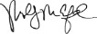​  Molly M. Crawford  Corporate Secretary
​
​
​
​
​
​
​
20
​
​
​
​
​
​
 | 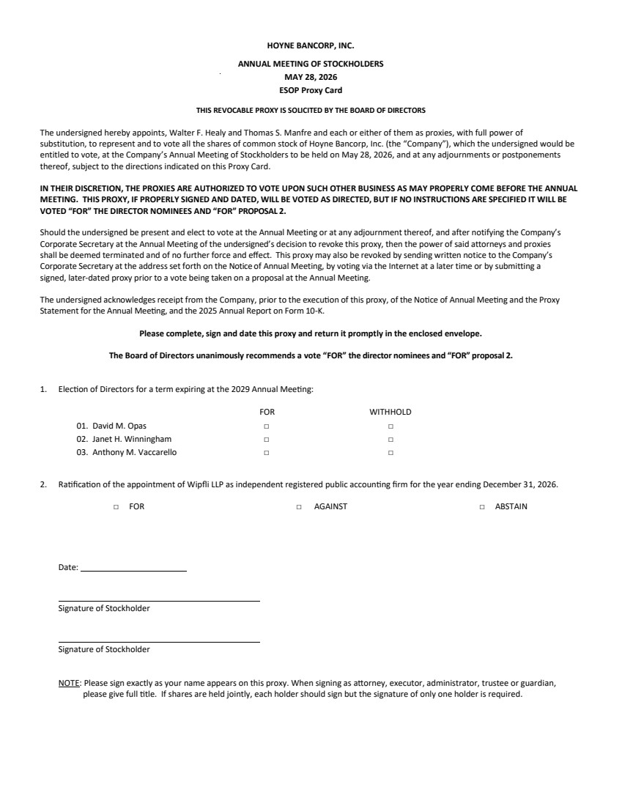 | HOYNE BANCORP, INC. ANNUAL MEETING OF STOCKHOLDERS MAY 28, 2026 ESOP Proxy Card THIS REVOCABLE PROXY IS SOLICITED BY THE BOARD OF DIRECTORS The undersigned hereby appoints, Walter F. Healy and Thomas S. Manfre and each or either of them as proxies, with full power of substitution, to represent and to vote all the shares of common stock of Hoyne Bancorp, Inc. (the “Company”), which the undersigned would be entitled to vote, at the Company’s Annual Meeting of Stockholders to be held on May 28, 2026, and at any adjournments or postponements thereof, subject to the directions indicated on this Proxy Card. IN THEIR DISCRETION, THE PROXIES ARE AUTHORIZED TO VOTE UPON SUCH OTHER BUSINESS AS MAY PROPERLY COME BEFORE THE ANNUAL MEETING. THIS PROXY, IF PROPERLY SIGNED AND DATED, WILL BE VOTED AS DIRECTED, BUT IF NO INSTRUCTIONS ARE SPECIFIED IT WILL BE VOTED “FOR” THE DIRECTOR NOMINEES AND “FOR” PROPOSAL 2. Should the undersigned be present and elect to vote at the Annual Meeting or at any adjournment thereof, and after notifying the Company’s Corporate Secretary at the Annual Meeting of the undersigned’s decision to revoke this proxy, then the power of said attorneys and proxies shall be deemed terminated and of no further force and effect. This proxy may also be revoked by sending written notice to the Company’s Corporate Secretary at the address set forth on the Notice of Annual Meeting, by voting via the Internet at a later time or by submitting a signed, later-dated proxy prior to a vote being taken on a proposal at the Annual Meeting. The undersigned acknowledges receipt from the Company, prior to the execution of this proxy, of the Notice of Annual Meeting and the Proxy Statement for the Annual Meeting, and the 2025 Annual Report on Form 10-K. Please complete, sign and date this proxy and return it promptly in the enclosed envelope. The Board of Directors unanimously recommends a vote “FOR” the director nominees and “FOR” proposal 2. 1. Election of Directors for a term expiring at the 2029 Annual Meeting: FOR WITHHOLD 01. David M. Opas □ □ 02. Janet H. Winningham □ □ 03. Anthony M. Vaccarello □ □ 2. Ratification of the appointment of Wipfli LLP as independent registered public accounting firm for the year ending December 31, 2026. □ FOR □ AGAINST □ ABSTAIN Date: Signature of Stockholder Signature of Stockholder NOTE: Please sign exactly as your name appears on this proxy. When signing as attorney, executor, administrator, trustee or guardian, please give full title. If shares are held jointly, each holder should sign but the signature of only one holder is required.
 | 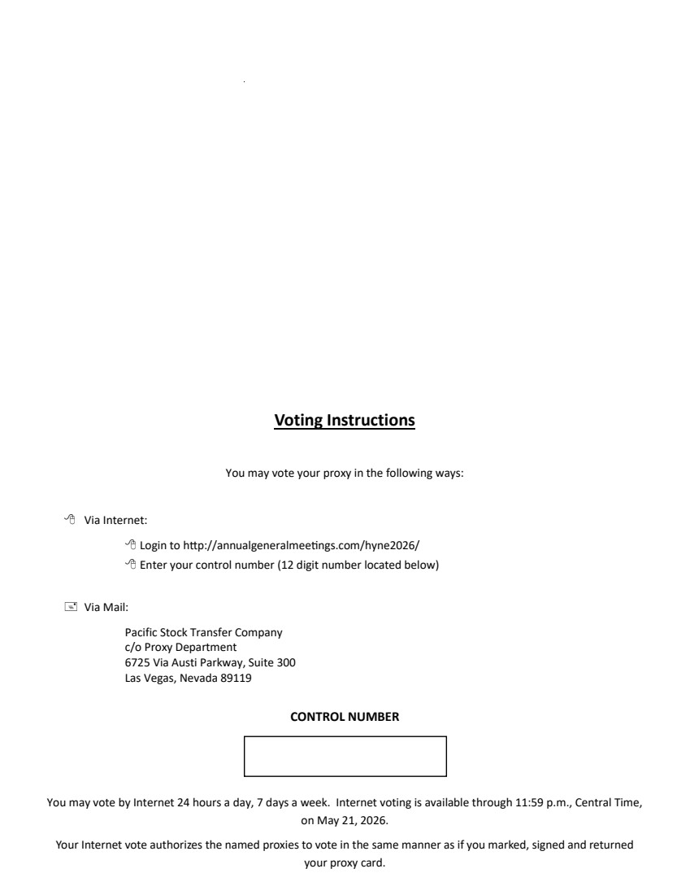 | Voting Instructions You may vote your proxy in the following ways:  Via Internet:  Login to http://annualgeneralmeetings.com/hyne2026/  Enter your control number (12 digit number located below)  Via Mail: Pacific Stock Transfer Company c/o Proxy Department 6725 Via Austi Parkway, Suite 300 Las Vegas, Nevada 89119 CONTROL NUMBER You may vote by Internet 24 hours a day, 7 days a week. Internet voting is available through 11:59 p.m., Central Time, on May 21, 2026. Your Internet vote authorizes the named proxies to vote in the same manner as if you marked, signed and returned your proxy card.
 | 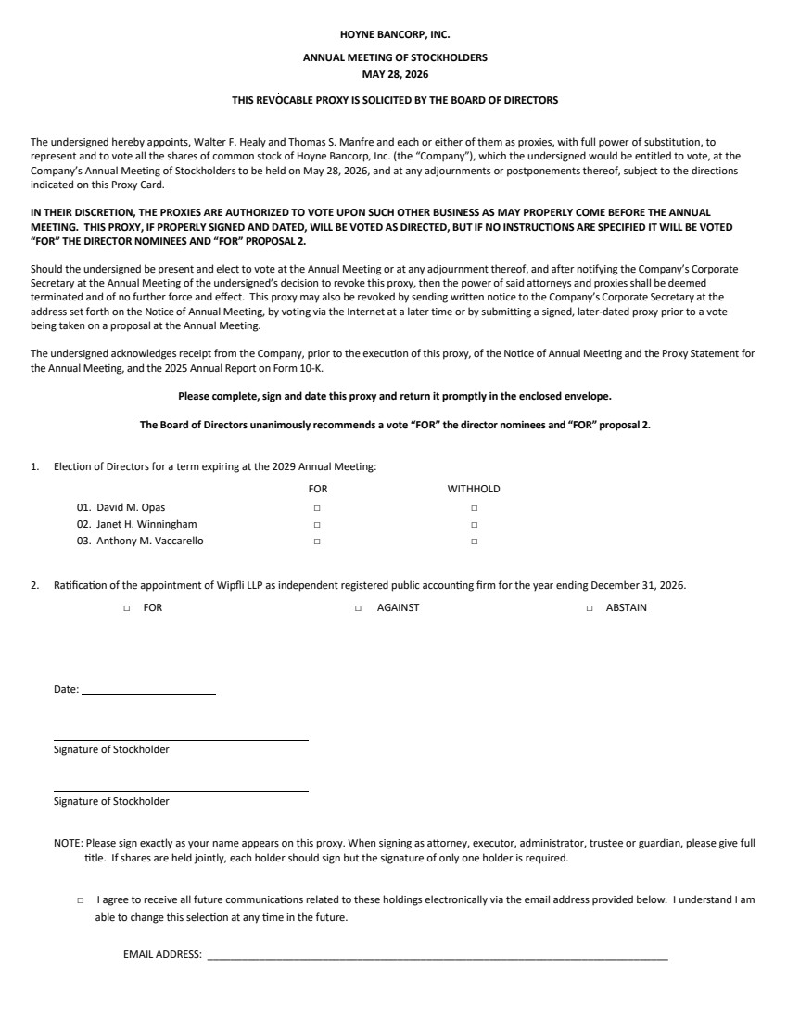 | HOYNE BANCORP, INC. ANNUAL MEETING OF STOCKHOLDERS MAY 28, 2026 THIS REVOCABLE PROXY IS SOLICITED BY THE BOARD OF DIRECTORS The undersigned hereby appoints, Walter F. Healy and Thomas S. Manfre and each or either of them as proxies, with full power of substitution, to represent and to vote all the shares of common stock of Hoyne Bancorp, Inc. (the “Company”), which the undersigned would be entitled to vote, at the Company’s Annual Meeting of Stockholders to be held on May 28, 2026, and at any adjournments or postponements thereof, subject to the directions indicated on this Proxy Card. IN THEIR DISCRETION, THE PROXIES ARE AUTHORIZED TO VOTE UPON SUCH OTHER BUSINESS AS MAY PROPERLY COME BEFORE THE ANNUAL MEETING. THIS PROXY, IF PROPERLY SIGNED AND DATED, WILL BE VOTED AS DIRECTED, BUT IF NO INSTRUCTIONS ARE SPECIFIED IT WILL BE VOTED “FOR” THE DIRECTOR NOMINEES AND “FOR” PROPOSAL 2. Should the undersigned be present and elect to vote at the Annual Meeting or at any adjournment thereof, and after notifying the Company’s Corporate Secretary at the Annual Meeting of the undersigned’s decision to revoke this proxy, then the power of said attorneys and proxies shall be deemed terminated and of no further force and effect. This proxy may also be revoked by sending written notice to the Company’s Corporate Secretary at the address set forth on the Notice of Annual Meeting, by voting via the Internet at a later time or by submitting a signed, later-dated proxy prior to a vote being taken on a proposal at the Annual Meeting. The undersigned acknowledges receipt from the Company, prior to the execution of this proxy, of the Notice of Annual Meeting and the Proxy Statement for the Annual Meeting, and the 2025 Annual Report on Form 10-K. Please complete, sign and date this proxy and return it promptly in the enclosed envelope. The Board of Directors unanimously recommends a vote “FOR” the director nominees and “FOR” proposal 2. 1. Election of Directors for a term expiring at the 2029 Annual Meeting: FOR WITHHOLD 01. David M. Opas □ □ 02. Janet H. Winningham □ □ 03. Anthony M. Vaccarello □ □ 2. Ratification of the appointment of Wipfli LLP as independent registered public accounting firm for the year ending December 31, 2026. □ FOR □ AGAINST □ ABSTAIN Date: Signature of Stockholder Signature of Stockholder NOTE: Please sign exactly as your name appears on this proxy. When signing as attorney, executor, administrator, trustee or guardian, please give full title. If shares are held jointly, each holder should sign but the signature of only one holder is required. □ I agree to receive all future communications related to these holdings electronically via the email address provided below. I understand I am able to change this selection at any time in the future. EMAIL ADDRESS: ________________________________________________________________________________
 | 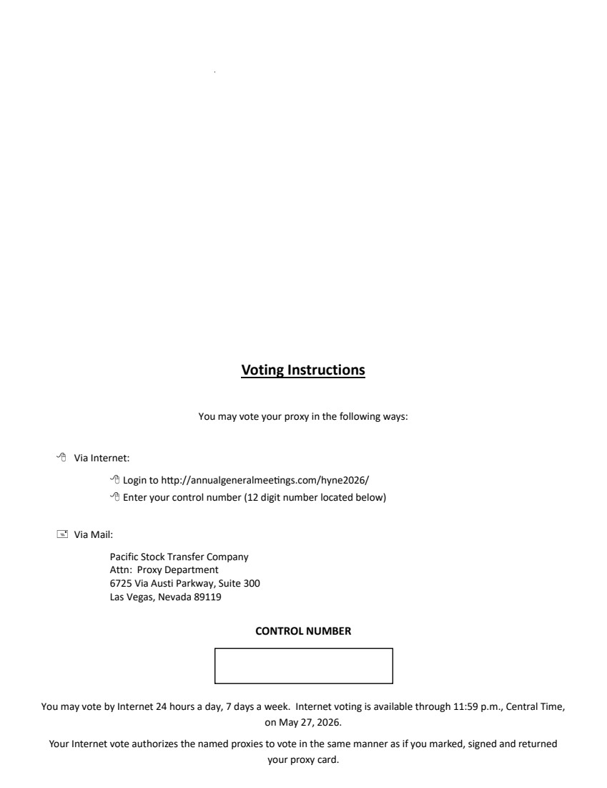 | Voting Instructions You may vote your proxy in the following ways:  Via Internet:  Login to http://annualgeneralmeetings.com/hyne2026/  Enter your control number (12 digit number located below)  Via Mail: Pacific Stock Transfer Company Attn: Proxy Department 6725 Via Austi Parkway, Suite 300 Las Vegas, Nevada 89119 CONTROL NUMBER You may vote by Internet 24 hours a day, 7 days a week. Internet voting is available through 11:59 p.m., Central Time, on May 27, 2026. Your Internet vote authorizes the named proxies to vote in the same manner as if you marked, signed and returned your proxy card.

